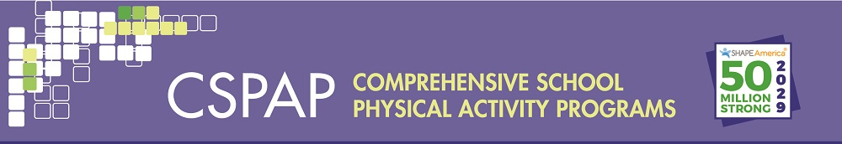
Table 2A.Developing Program Outcomes and Indicators-School Level
School Level
Vision | Goal | Objective | Outcome | Indicator(s)
 | Goal 1: | Objective: | Short/Intermediate/Long
 | Goal 2: | Objective: | Short/Intermediate/Long

